Business Requirements

Program Name: | GSO | Program Manager:
Project Name: | GSO – PO / Invoice On SupplierNet | Project Manager:
Project Number: |  | Account Unit:
Sponsor: |  | Business Owner:

Document Version Control
Date | Version # | Describe Revision(s) | Author(s)
05/20/2011 | 1.0 | Initial version | Cognizant
05/23/2011 | 1.1 | Updated Exception Report requirements | Cognizant
05/24/2001 | 1.2 | Updated Section 4, 5,6 and 7 | Cognizant
05/24/2001 | 1.3 | Updated with new scopes | Cognizant

Table of Contents
1 Document Overview 3
1.1 Business Objectives 3
1.2 Business Benefits 3
1.3 In Scope 3
2 GSO Process Flow 4
3 AS-IS Process flow for DC_PO_ASN 5
4 AS-IS Web methods Flow 6
5 TO-BE Process flow in Web methods for GSO PO 9
6 To BE Process Flow for Exception Report 10
7 Assumptions 10
8 Out-Of-Scope 11
9 Dependencies 11
10 Integration with other systems 12
10.1 Changes in Other Applications 12
10.2 Non Functional Requirements 12
10.3 Performance 12
10.4 Scalability 12
10.5 Availability 12

Document Overview

This document covers business requirements for implementing GSO functionality in SupplierNet. Walgreens plans to open Global Sourcing Office in china which will act as an import vendor for Walgreens USA. This global sourcing office will deal with import vendors within china. There is a need to allow these import vendors to submit invoice against the ASN submitted by freight forwards. This document details the changes required to allow an import vendor to submit invoice against import PO on SupplierNet.

Business Objectives

- Providing an online access for Import Vendors to submit invoice against the ASN Submitted by Freight Forwarder.
- Providing facility for Import Vendors to submit invoice against Import PO on Supplier Net

Business Benefits
- Import vendor can submit invoice against import PO on SupplierNet.

In Scope

- Webmethods has to identify the Non EDI Compatible ASN records and submits the all those records to the Vendor Portal Database.
- An alert email has to be sent to the vendor to inform ASN is ready for Invoice creation.
- Exception report should be generated and viewed online in the supplier net portal.
- An email has to be sent ‘Accounting User’s with the report link after the report generation.

GSO Process Flow

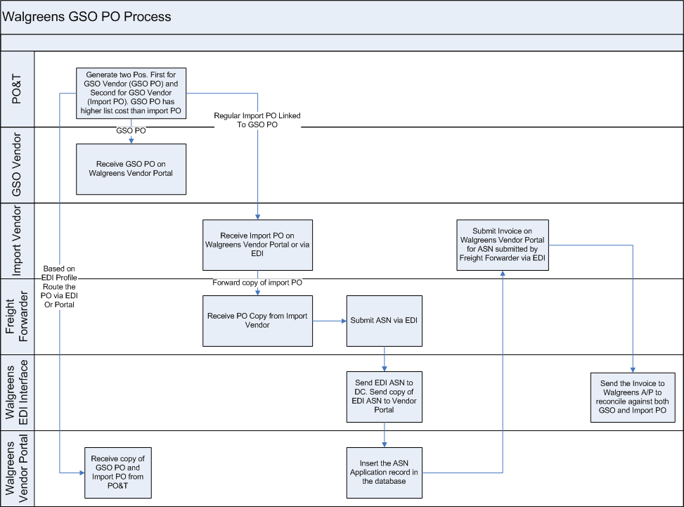

- PO&T generates two POs. One PO is sent to Walgreens GSO Office and second PO is a regular import PO
- Vendor forwards the import PO copy to freight forwarder
- Freight forwarder submits ASN via EDI
- Walgreens EDI team sends a copy of the ASN to vendor portal
- Based on the ASN, vendor portal allows the vendor to submit Invoice

AS-IS Process flow for DC_PO_ASN

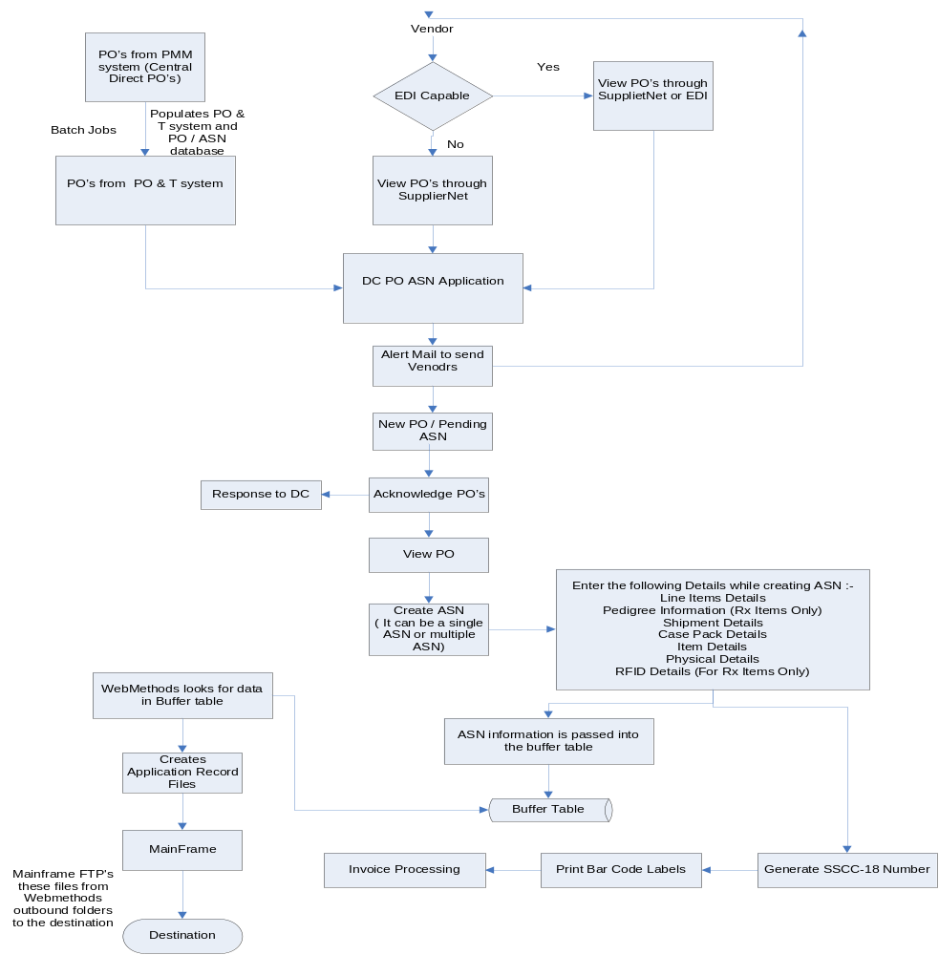

AS-IS Web methods Flow
WebMethods is used to integrate the application to the Walgreens mainframe system. They are implemented as an EDI communication tool to work in parallel with the current GENTRAN (Mainframe) system. Implementing the vendor portal integration allows vendors to collaborate with Walgreen’s via the portal and/or inexpensive EDI.

Vendor Portal Integration Overview

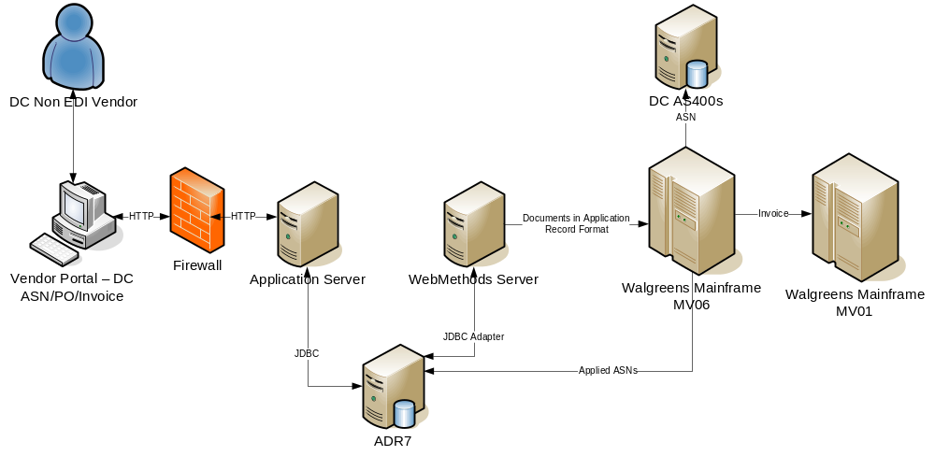
High Level Logical Architecture
- Buffer tables for PO, ASN and invoice header tables of the DC PO/ASN/invoice application are maintained to increase the performance. The application inserts records into the buffer tables when a FA, ASN or invoice is submitted. Notification services at webMethods continuously poll the tables for insertions.
- JDBC adapters are used for the connecting to AS400 database.
- JDBC Basic Notification is used to alert webMethods services when new records are inserted into PO, ASN and invoice buffer tables. The webMethods service polls the database repeatedly to check for new records.
- Generation of FA overdue reports is through an hourly scheduled batch process (configurable within webMethods).
- To prevent issues arising out of mainframe accessing files that webMethods has not finished writing, the mainframe pick files that have an .RDY extension (indicating that the file is ready for further processing) only.
- The mainframe renames the file after picking up the file for processing.

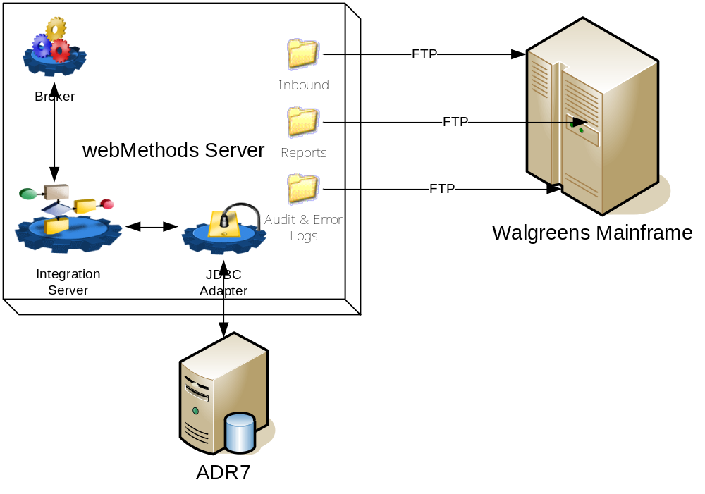
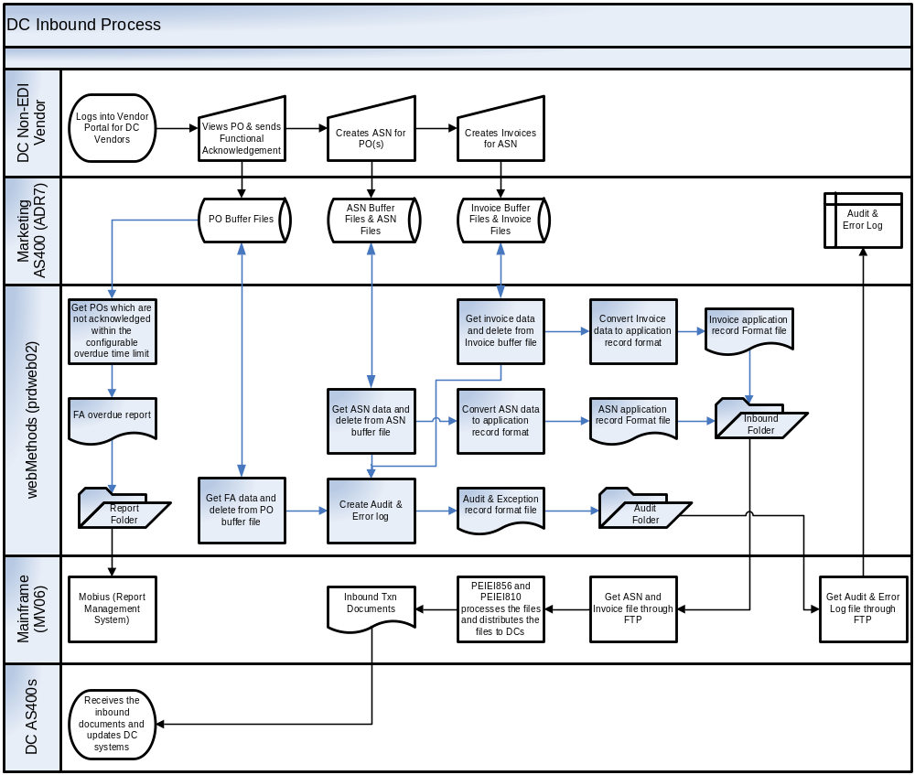

TO-BE Process flow in Web methods for GSO PO

- In GSO, since freight forwarders creates ASN thru EDI and they submit all the ASN records thru EDI (Both EDI Compatible & Non EDI Compatible) and places into the File System.
- Webmethods has to identify up only the Non EDI Compatible records and submits the records to the Vendor Portal Database.
- Processed ASN application records in the new inbound folder should be moved to a Backup folder as-is in current system.
- If there are any ASN Header updates,webMethods will only update the respective ASN header

To BE Process Flow on Portal
- After webMethods ASN updation into the portal DB, and alert email has to be sent to the Vendors.
- When the ‘Import Vendor’ clicks on ‘Submit Invoice’ Button in DC_PO_ASN application, application has to compare the PO record and the ASN records .If there are any variances those details should be updated into a single table in the database. New table should be used for the same
- After generating the report an email has to be sent to “Accounting Team Users”.
- In the reports section a new link should be added for the Exception reports along with the existing report links.
- ‘Accounting Team Users’ only will have access to these reports.
- When any of the Accounting users clicks on the Exception Report link, page should be displayed with filters.
- Page UI should have the same look &feel of existing reports.
- User should able to view the reports based on the filters (for ex: Vendor No, ASN, Invoice No and PO NO).
- The generated report should display in the same page as-is like existing reports.

Exception Generation Flow
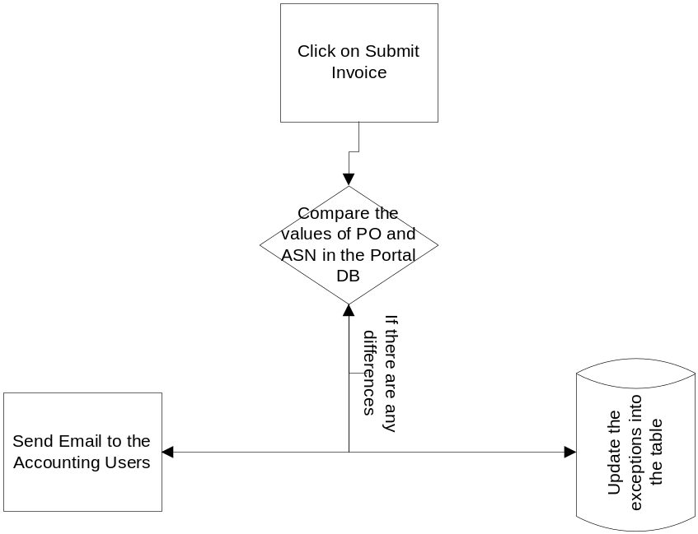

Assumptions
- Hence the ASN transaction volume and frequency is low, there is no performance risk.
- There are no changes in Invoice creation.
- There are no changes to the ASN application record format. It is same as the as-is ASN application records.
- If there is no way to find out not compatible EDI vendors in the ASN records , we will be importing all the ASN records
- As it is a small enhancement to DC_PO_ASN ,SDF Framework will be used
- Both the PO and associated ASN data will be available in the vendor portal DB which will be used by the portal application to compare and generate exception
- Any extra Report filters and Contents will be finalized during the Design Phase
- Email Communication message and to/from address will be baselined during the Design Phase, Inclusion of the supplier net portal link in the Email send to the user will be decided during detail requirement gathering phase.
- Download Exception Report is not in Scope.
- There is no additional scope included for sending the report in other formats to the user.
- Alert email format to the vendor and frequency details will be finalized after discussing with business.
- Items that do not appear on the PO will be considered as exception. ASN header comparison rules will be provided by business

Out-Of-Scope
- Changes to the PO& T System are not-in scope.
- File transfers using EDI from PO&T System to Web method server is not in scope.
- Help Files Changes are not in scope
- ASN item details will not be updated because of possibility of multiple ASNs per PO..

Dependencies
- This project has dependency with EDI Team as ASN application records will be delivered by them

Integration with other systems

Changes in Other Applications
NA

Non Functional Requirements
NA

Performance
Performance of the application will be aligned with other SupplierNet applications.

Scalability
Scalability of the application will be aligned with other SupplierNet applications.

Availability
Availability of the application will be aligned with other SupplierNet applications.

